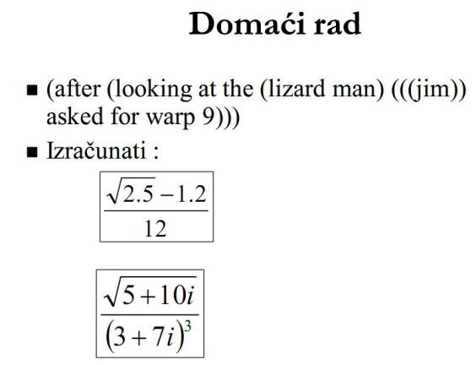

Tribalo je konstruirat prvi dio zadatka, ali ja sam i to i „izvadio“ JIM ☺

Koristio sam Cons di god sam moga, ali i List nisam moga izbjeći

( cons 'jim nil )
(jim)
( cons ( cons 'jim nil ) nil )
( ( jim ) )
( cons ( cons ( cons 'jim nil ) nil ) nil )
( ( ( jim ) ) )
( list ( cons ( cons 'jim nil ) nil ) 'asked )
( ( ( jim ) ) asked )
( list ( cons ( cons 'jim nil ) nil ) 'asked 'for 'warp '9 )
( ( ( jim ) ) asked for warp 9 )
( list ( list 'lizard 'man ) ( list ( cons ( cons 'jim nil ) nil ) 'asked 'for 'warp '9 ) )
ili
( list ( cons 'lizard ( cons 'man nil) ) ( list ( cons ( cons 'jim nil ) nil ) 'asked 'for 'warp '9 ) )
( ( lizard man ) ( ( ( jim ) ) asked for warp 9 ) )
( list 'looking 'at 'the)
( looking at the )
( list 'looking 'at 'the ( cons 'lizard ( cons 'man nil) ) ( list ( cons ( cons 'jim nil ) nil ) 'asked 'for 'warp '9 ) )
( looking at the ( lizard man ) ( ( ( jim ) ) asked for warp 9 ) )
( list 'after ( list 'looking 'at 'the ( cons 'lizard ( cons 'man nil) ) ( list ( cons ( cons 'jim nil ) nil ) 'asked 'for 'warp '9 ) ) )
( after ( looking at the ( lizard man ) ( ( ( jim ) ) asked for warp 9 ) ) )
( setq sentence ( list 'after ( list 'looking 'at 'the ( cons 'lizard ( cons 'man nil) ) ( list ( cons ( cons 'jim nil ) nil ) 'asked 'for 'warp '9 ) ) ) )
( after ( looking at the ( lizard man ) ( ( ( jim ) ) asked for warp 9 ) ) )
( cdr sentence )
( ( looking at the ( lizard man ) ( ( ( jim ) ) asked for warp 9 ) ) )
( car ( cdr sentence ) )
( looking at the ( lizard man ) ( ( ( jim ) ) asked for warp 9 ) )
( car ( car ( cdr sentence ) ) )
looking
( cdr ( car ( cdr sentence ) ) )
( at the ( lizard man ) ( ( ( jim ) ) asked for warp 9 ) )
( cdr ( cdr ( cdr ( car ( cdr sentence ) ) ) ) )
( ( lizard man ) ( ( ( jim ) ) asked for warp 9 ) )
( car ( cdr ( cdr ( cdr ( car ( cdr sentence ) ) ) ) ) )
( lizard man )
( cdr ( cdr ( cdr ( cdr ( car ( cdr sentence ) ) ) ) ) )
( ( ( ( jim ) ) asked for warp 9 ) )
( car ( cdr ( cdr ( cdr ( cdr ( car ( cdr sentence ) ) ) ) ) ) )
( ( ( jim ) ) asked for warp 9 )
( car ( car ( cdr ( cdr ( cdr ( cdr ( car ( cdr sentence ) ) ) ) ) ) ) )
( ( jim ) )
( car ( car ( car ( cdr ( cdr ( cdr ( cdr ( car ( cdr sentence ) ) ) ) ) ) ) ) ) )
( jim )
( car ( car ( car ( car ( cdr ( cdr ( cdr ( cdr ( car ( cdr sentence ) ) ) ) ) ) ) ) ) )
jim
( / ( - ( sqrt 2.5 ) 1.2 ) 12 )
0.031761568
( / ( sqrt #c ( 5 10) ) ( expt #c (3 7) 3 ) )
#c(-0.007422733 -0.0014849929)

